Managing BCD’s WebSmart ILE
With
Aldon ALM Solutions

Last updated: June 21, 2012

Managing BCD’s WebSmart ILE 1
Prolog 2
What is BCD’s WebSmart ILE? 2
What is Aldon’s Application Lifecycle Management Solution 2
Part I: Overview 4
How Are the Products Working Together? 4
How is Aldon Managing the Process? 4
How is Aldon Managing Deployment? 5
Part II: Setup 7
LM(i) Setup for library-based artifacts 7
Compiling the Generate ILE Source 7
Development 8
Job Description 9
QA 9
Production 10
LM(e) Setup for Directory-based Artifacts 10
DM Setup for Library-based Artifacts 12
DM Setup for Directory-based Artifacts 12
WebSmart ILE Setup 14
HTTP Server Setup 16

Prolog
This document has been created as assistance to someone desiring to manage BCD’s WebSmart ILE with Aldon’s ALM solution. The guide is not meant to be an exhaustive step-by-step roadmap; a great degree of knowledge of both products is assumed. The reader is strongly encouraged to consult the Technical Support teams at both Aldon and BCD for additional assistance.

Aldon Computer Group makes no warranty, express or implied, with regard to this material, including fitness for use. Additionally, Aldon is not responsible for maintaining compatibility of this information with future releases of either Aldon’s or BCD’s solutions. Aldon provides this as an example only. Customers using this information do so at their own risk.

What is BCD’s WebSmart ILE?
WebSmart ILE is an IBM i modernization tool. It can take as input your existing DB2 database files and quickly generate web applications to interface with them. WebSmart’s IDE is a client-based solution that generates RPG ILE-CGI source and objects natively on the IBM i. WebSmart will then run these CGI programs in the HTTP server that also runs natively on the IBM i to provide the web interface.

What is Aldon’s Application Lifecycle Management Solution
Aldon is a leading ALM vendor with many years of experience providing best-practice ALM solutions to companies both small and large. The solution is comprised of three main tools:
- Community Manager: Provides project and issue management for those requests requiring changes to your software applications
- Lifecycle Manager: Provides a central inventory of every artifact that comprises any software application across your enterprise, regardless of platform. With all of your artifacts centrally stored, LM then provides solid workflow management to the changes that are occurring to your applications on a daily basis. This workflow includes, for example, check out, check in, promote, deploy, get latest, archive, history, compare, emergency processing and much more.
  - Lifecycle Manager for IBM i LM(i): This manages any artifacts that are library-based.
  - Lifecycle Manager Enterprise LM(e): This manages any artifacts that are directory-based. LM(e) also gives you vision and management of the library-based artifacts controlled by LM(i).
- Deployment Manager: Managing the central inventory is an essential part of the ALM process, but this is not where your live applications are being served. It is the job of Deployment Manager to get the right part to the right locations in a highly automated fashion that is, at the same time, reliable and auditable. DM also provides functionality for speedy rollbacks if something is applied that was not desired.

Part I: Overview

How Are the Products Working Together?
WebSmart’s IDE uses a program definition file with an extension of .pdw (Program Definition – WebSmart). Once the developer has made the desired changes to the PDW, he/she clicks the “generate” button. Based on the PDW, WebSmart generates the ILE-CGI source on the IBM i. WebSmart then invokes the RPG compiler to generate the CGI ILE program that will eventually drive the web application.

As the primary driver of the entire application, solid management of the PDW is essential. LM(e) will keep all PDW’s stored in its central inventory. Programmers will use LM to quickly locate and checkout the PDW they want to alter. They will also use LM(e) to check out the corresponding RPG source/object of the same name.

Once checked out, they will simply double click on the PDW from the LM(e) interface to open WebSmart’s IDE on that item. They will make their changes and then generate the corresponding RPG source and object. At this point, they simply return back to LM to check in the PDW and the RPG, promote it on through to production and (optionally) deploy it to other partitions/machines.

How is Aldon Managing the Process?
All of the necessary artifacts that drive the WebSmart application will be stored in LM’s central inventory. This certainly means the PDW and the generated RPG source and object. However, it also means the entire DB2 database, other IBM i programs, CSS, HTML, XML, word documents, gif’s, jpg’s and anything else that is critical to the functionality of the application.

Aldon highly recommends that all development activity be task-centered. This certainly helps developers be more organized and focused. The benefits, however, extend far beyond just the developers. The task helps document the changes, closely associating the objects changed with the task that drove those changes. This is extremely useful when QA testing is done. Once QA testing is accomplished, the promotion to production is made much easier if it is done by task, ensuring all the necessary changes, on all platforms, are taken into live production together. After promotion, the task remains in LM’s history forever as an on-going documentation of past changes. This is very important for those companies who have to prove audit compliance. It is also extremely useful during emergency situation where fast access to complete documentation of the offending objects is essential.

Once the task is created, checkout of the desired artifacts may commence. The objects are selected from LM’s central inventory panel and a single click processes the checkout request. Note that both the PDW and the associated RPG artifacts must be checked out. This is because the developer will eventually be overlaying this RPG source and object and promoting it back up. Aldon automatically marks the objects as checked out and records this information in the history log. The directory-based artifacts (e.g. the PDW) are copied out of the inventory and down to the programming workspace (typically the programmer’s C drive).

Development now happens within the WebSmart IDE. Once all changes are made to the PDW, the developer will click the “generate” button and this instructs WebSmart to generate the RPG source and object onto the specified development library on the IBM i. If the unit testing is successful, the objects are ready to be checked back in via LM.

What happens next depends on how many environments are defined in LM between development and production. Aldon certainly recommends at least having one environment for Quality Assurance testing. When the developer does a check in of the PDW and the RPG, LM moves the PDW, the RPG source and the RPG program from the developer’s workspace to the QA environment defined to LM.

For the PDW, this means that the PDW is copied into LM’s repository. Depending on the settings in LM, the code in the developer’s workspace is either deleted, or kept there but set to “read only”. Note that artifacts in LM’s repository cannot be accessed outside of LM. If you wish to change them, you need to check them out. If you wish to execute them, you must deploy them to another location, e.g. your QA directory. We’ll talk more on deployment shortly.

When the developer checks in the RPG, LM(i) is promoting the source and recompiling the RPG source and object into the library designated for QA on the development i. This automatically updates the Aldon cross reference database at the same time. By default, LM(i) removes the object from the originating environment upon a successful promotion. However, WebSmart requires a full compliment of all objects in each environment. To accomplish this, an LM(i) exit program for the i has been created that will copy the changed artifacts (object only, not source) back to the programmer’s library after a success promotion to QA.

How is Aldon Managing Deployment?
Upon check in, the PDW is returned to the QA environment of the LM inventory and the RPG source and object are moved to the QA libraries on the development IBM i. It is Aldon’s recommendation that actual QA testing is not done from this library because our next promotion up into production will remove the promoted objects out of this library. For WebSmart to function correctly, a full compliment of objects must be maintained at each environment. The objective is to keep the libraries that LM is using for its promotion path completely separate from the libraries WebSmart is using to serve its QA and production applications.

To accomplish this, Aldon recommends using the Aldon Deployment Manager for IBM i solution. DM will take the objects being promoted (at any environment), save them, send them to the target machine(s), receive them and install them into the proper target library. If your target is on a separate machine or lpar, you will need to purchase a DM client for that machine. If your target is merely a different library on the same machine as development, then no additional purchases are necessary because LM comes equipped with a built in DM client.

Using the DM client gives you additional benefits in the following areas:
- Scheduling
- Separation of duties
- Rollback
- Ease of use

Note that the PDW does not need to be deployed as it does not drive the actual application. Its final resting place is the production environment in the LM inventory, waiting for the next checkout request. However, if you are also changing supporting artifacts such as CSS or HTML, these artifacts must be deployed to WebSmart’s IFS directory on the serving IBM i machine. Aldon recommends using the Deployment Manager for Enterprise client in this situation.

Part II: Setup

LM(i) Setup for library-based artifacts
You will create a release on your development IBM i to maintain each of your unique WebSmart applications. You may name your group/application/release anything that helps you better organize your inventory. For example, I created a group/application/release on my development box ALDMO1 called ALDON/WHOLESALE/BASE.

You can have 0, 1 or 2 environments in between Dev and Production, as you wish. Aldon highly recommends that you at least have one for QA. For reference sake, I defined three environments in my application, Dev, QA and Production.

Compiling the Generate ILE Source
One of the hallmarks of a good SCM system is its ability to ensure that the object is compiled correctly at every level of its existence. This means that a promotion will typically move the source code to the target environment and then compile it again against a compile-time library list that is appropriate for that environment. This helps prevent level-checks where the object is not in synch with the databases that are also at that same environment. Additionally, by compiling the source, Aldon is able to ensure that the cross reference meta-data is kept up to date for the application.

During the generation of the ILE source, WebSmart inserts some custom compile directives as comments at the beginning of the source member. These compile directives are read by WebSmart’s custom compile command, ECRTCGI, to accurately generate the final bound ILE object. Once we have taught LM to use this create command, it will be used for every manual compile (e.g. 14 on a developer’s copy) and every automated compile (e.g. during promotion).

From the Work with Applications panel, select Option 2, Change. Then select Option 5: Work with definitions of commands that create objects. Fill in the parms as shown in the screen shot below. Note that the job description parm is set to *NONE, this enables the create command to be run interactively inside of the Aldon compile/promote job. Without this, the command is submitted as a separate batch job and the Aldon promote will fail. Also note that we are doing this set up at the application level. This ensures that only this application and its child releases will be affected by this custom create command.
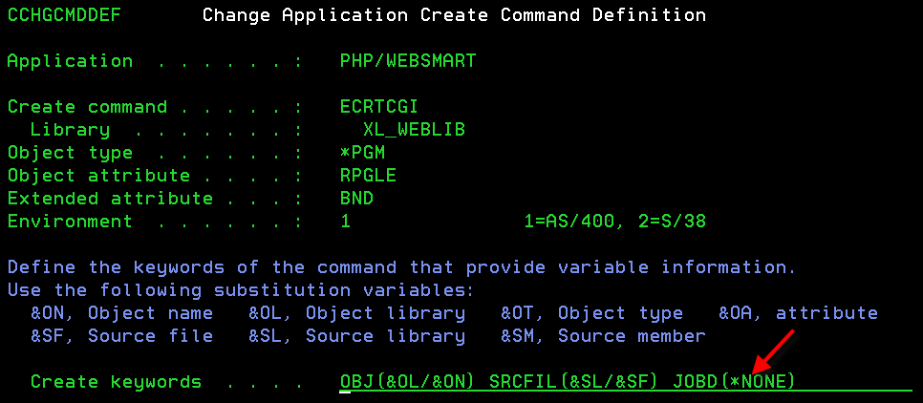

Once you have the command defined to LM, you need to instruct LM what types of objects are managed by this custom command. Take Option 2 to change the release, then Option 6: Edit Defaults for Object Creation:
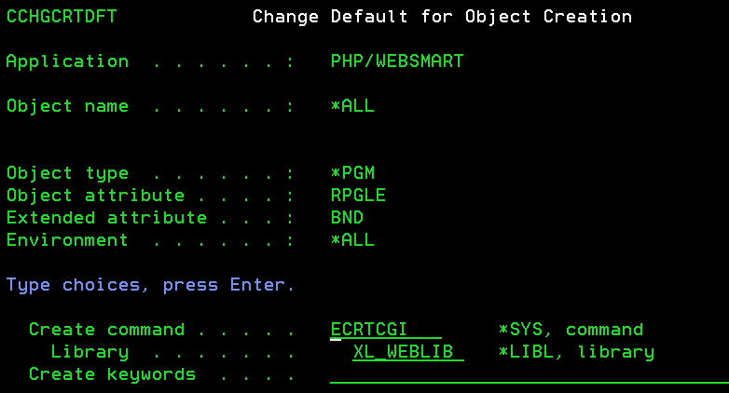

Development
This is the location where development will be staged on the development IBM i. Most importantly, this must match where the user’s IDE has been configured to generate the RPG source and object.

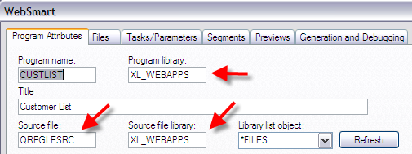

In the screen shot above, I have set up my WebSmart IDE to generate the RPG source and object to library XL_WEBAPPS. This will match my developer profile record in LM(i) that control where LM(i) places the checked out source.

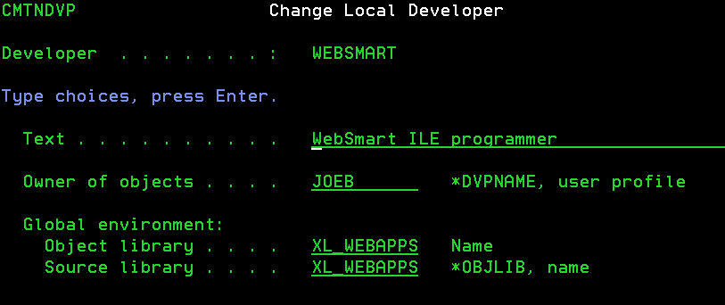

Job Description
In order for the LM(i) batch promotion job to find the WebSmart ILE compiler, you need to create a custom *JOBD which has XL_WEBLIB and XL_WEBDEMO in the library list. Once you have this *JOBD created, change the LM(i) release to submit jobs to this *JOBD.

QA
There are several special considerations for setting up your QA environment.
IBM i Deployment: You will want to turn on deployment to your LM QA deployment profile. You may want to configure it so that there is no choice but to deploy upon promotion.

Exit Program: Most likely, each developer will want a full complement of objects to remain in his/her programming library so they can do a good unit test with WebSmart. In order to accomplish this, a simple exit program can be created that will perform a CRTDUPOBJ of the promoted objects (not source) back to the programmer’s library after a successful promotion. This program will be invoked after all promotions for this release:

The program should be compiled to adopt enough authority to be able to manipulate the objects in both the QA and the developers’ libraries.

Here is a sample except of code for the exit:
NXTREC: RCVF
MONMSG MSGID(CPF0864) EXEC(GOTO CMDLBL(ENDPGM))

/* IF THE OBJECT IS NOT COMING FROM DEVELOPMENT, SKIP IT */
IF COND(&FRMENV *NE 'DVP') THEN(GOTO +
CMDLBL(ENDPGM))

/* DUPLICATE THE OBJECT FROM THE QA LIBRARY BACK TO DEVELOPER */
IF COND(&OBJATTR = 'PF') THEN(DO)
CRTDUPOBJ OBJ(&OBJNAME) FROMLIB(&TOOBJLIB) +
OBJTYPE(&OBJTYPE) TOLIB(&FRMOBJLIB) +
DATA(*YES)
ENDDO
ELSE (DO)
CRTDUPOBJ OBJ(&OBJNAME) FROMLIB(&TOOBJLIB) +
OBJTYPE(&OBJTYPE) TOLIB(&FRMOBJLIB)
ENDDO

GOTO CMDLBL(NXTREC)

Production
IBM i Deployment: You will want to turn on deployment to your LM production deployment profile. You may want to configure it so that there is no choice but to deploy upon promotion.

LM(e) Setup for Directory-based Artifacts
For the same reasons that we needed an LM(i) release structure to manage the library-based components of our WebSmart application, you will also need an LM(e) release structure to manage the directory-based components. In fact, since the PDW is the source of the eventual RPG that drives the application, managing the PDW is essential. As mentioned before, many companies choose to extend WebSmart ILE with their own css, html, xml, gif and jpg artifacts. If these artifacts are a part of the final web application, they definitely should be managed by an LM release.

You will create an LM(e) release to maintain each of your unique WebSmart applications. You may name your group/application/release anything that helps you better organize your inventory. For example, I created a group/application/release called AldonDemo/Wholesale/Base(1.0). You can have as many environments in between Dev and Production, as you wish. Aldon highly recommends that you at least have one for QA. For reference sake, I defined three environments in my application, Dev, QA and Production.

The LM(e) release is pretty much standard issue, with just a few notes.

Be sure you link this release to the LM(i) library-based release you created above
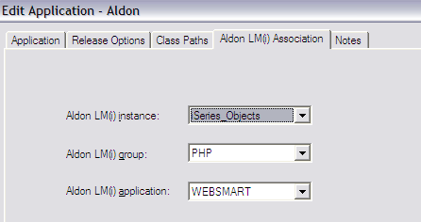

Directory-based Deployment: If you choose to also manage directory-based artifacts that are associated with your web pages (e.g. css, gif, conf), then you will also need to configure deployment in the directory-based LM/DM tools. Once you have that configured, you will activate in the LM release here:

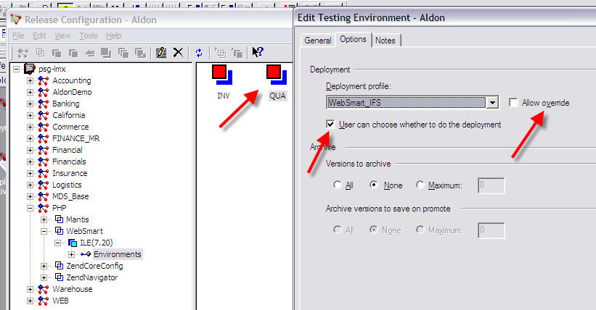

DM Setup for Library-based Artifacts
You will need to configure two deployment profiles for each release, one for QA deployments and one for live production deployments. Aldon recommends that both of these deployment profiles be configured as “live” deployments which enable the maximum amount of automation and ease of use.

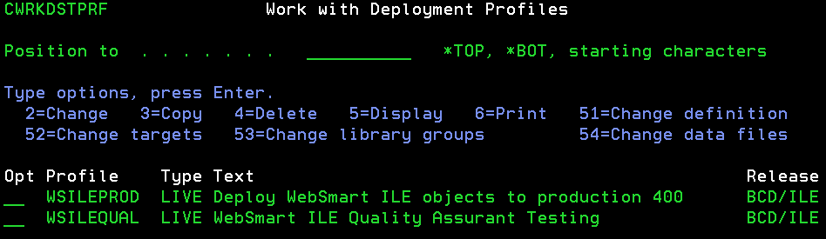

Nothing out of the ordinary needs to be done when configuring these deployment profiles. They only thing to remember is that we only need the objects to be deployed, source can stay on the development box.

DM Setup for Directory-based Artifacts
If you are you have chosen to also manage the directory-based artifacts that affect your web application (e.g. css, gif, conf), then you will also need to deploy those to the directory from which WebSmart serves your application. In the default configuration of WebSmart ILE, this directory is in the IFS of the IBM i. To accomplish this deployment, you will need the DM client that is capable of deploying to directories, not libraries. Please contact Aldon if you do not have this client.

To accomplish this deployment, you will need to configure a deployment profile for each target directory, e.g. one for production and one for QA (if you have a QA web server).

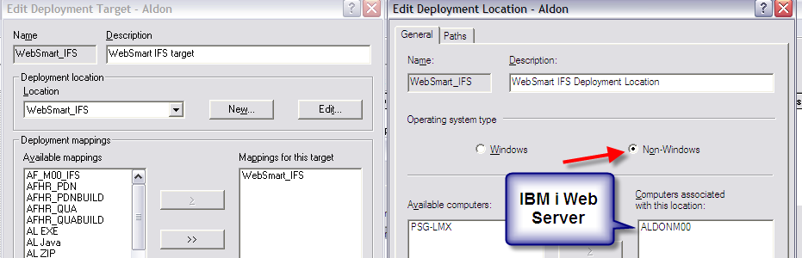

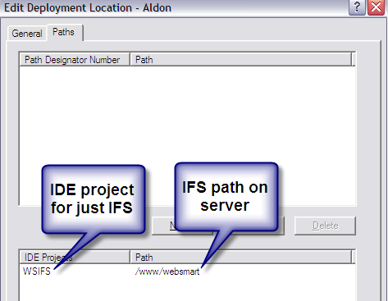

It is advisable configure the Deployment Profile to not deploy the PDW files. Remember that the PDW files are for development use only, they, themselves, do not drive the web application. Therefore, they are not needed on the production IFS directory. In fact, Aldon highly recommends that these objects be kept only in the LM inventory. This will ensure that all changes will be made only through the LM solution. To accomplish this, you will exclude parts with the “.pdw” extension from being deployed via the deployment profile’s mapping instructions.
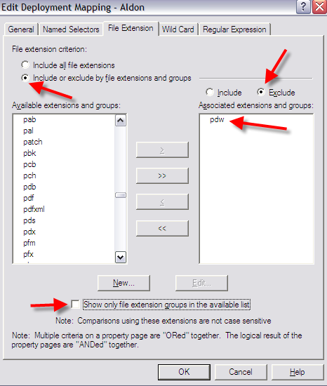

WebSmart ILE Setup
Near the beginning of the source code of every PDW there is a command that controls the IBM i library list that WebSmart will use to find the actual files which are referenced by the program at run time. Because Aldon is going to be moving this generated program from library to library and system to system, we need a method that will automatically sense where the object is and set the library list up accordingly. WebSmart gives us this technique via the special value “*OBJLIB”. (Note that program value “pgmf_pgmlib” will also work in the same fashion.) This field returns the value of the library where the current object is located. Passing this parameter value to the WebSmart setlibl command enables WebSmart to use the correct library list based on where LM has placed the code. This command will enable WebSmart to set the program’s run time library list correctly based on what environment LM has placed the object.

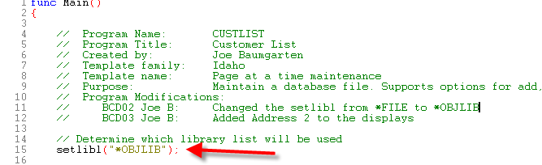

The WebSmart user guide mentions that you could “hard code” this setlibl value in the code templates that come shipped with the product so that future development has the value set this way by default. Please consult the WebSmart user guides or WebSmart Technical Support for more assistance with this.

In order for the setlibl command to work properly, there needs to be a special library list object defined in WebSmart on the target machine.

To access this:
- ADDLIBLE XL_WEBLIB
- EWRKLIBL.

When you run this command, you will see a screen that looks something like this:

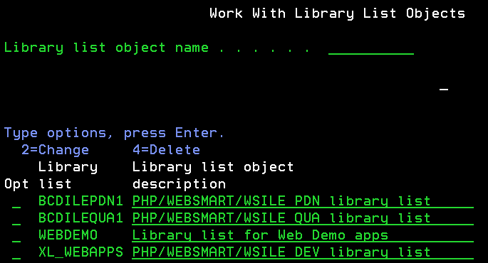

You will set up a WebSmart library list object for each environment that WebSmart is using on this machine. In my demo application, I have one for development (XL_WEBAPPS), QA (BCDILEQUA1) and Production (BCDILEPDN1). As you can surmise, these names match the targets of my LM release environments and DM deployment target libraries.

Inside each of these library list objects is a list of the actual libraries that must be in the library list at run time for WebSmart to function properly at this level. Remember that we are working with a Web application here, and each environment must have a full complement of database files. The QA library list should only specify QA libraries and no production libraries, for example.

More information on creating and maintaining these library list objects can be found in the WebSmart ILE Reference Guide.

HTTP Server Setup
The information in this section is not required for either Aldon or WebSmart to function. It is included because some companies might like to create additional QA servers and have LM deploy to those servers as part of their QA testing. WebSmart’s Reference Guide has much more detail on this topic.

WebSmart runs natively on the IBM i via the HTTP Apache Tomcat server. On each IBM i, you should see the QHTTPSVR subsystem running and at least the ADMIN and WEBSMART jobs running underneath that. If you are not seeing these, try running the STRTCPSVR SERVER(*HTTP) HTTPSVR(*ALL) command.

Once you see these jobs running, you can manage the servers on that box via the web address: http://172.25.8.113:2001/HTTPAdmin where 172.25.8.113 is the IP address of my IBM i.
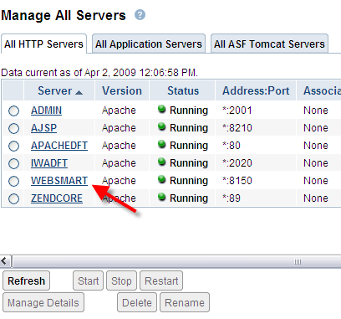

If you drill into the configuration of the WebSmart HTTP server, you will see that it is using files in the IFS. By default these files can be found in the root directory here:
/www/websmart/.

If you are deploying your WebSmart ILE objects to a specific library, you need to link that library with the web site by creating alias entries in the server’s configuration file. The configuration file can be found here: /www/websmart/conf/httpd.conf.

In the example below, I have told the WebSmart server to associate the “/live” directory with the BCDILEPDN1 library and the “/test” directory with BCDILEQUA1. As you saw above, these are the libraries that I have DM deploy into on my production machine.
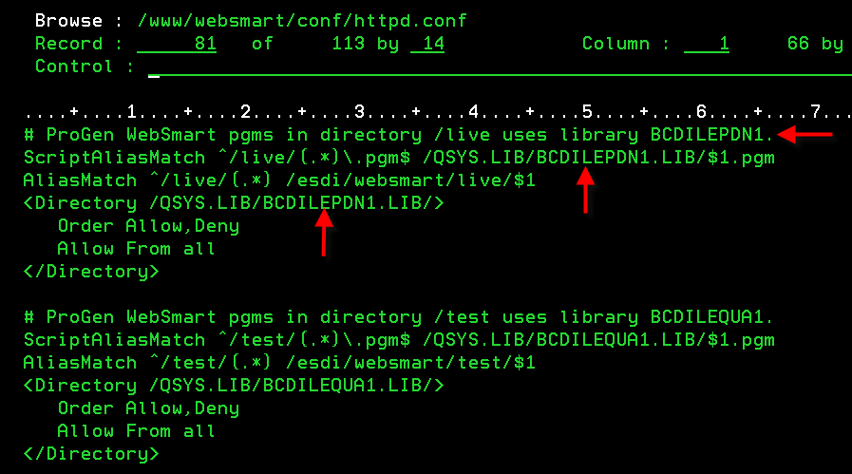

Now I can bring up either my test or my live WebSmart pages:
